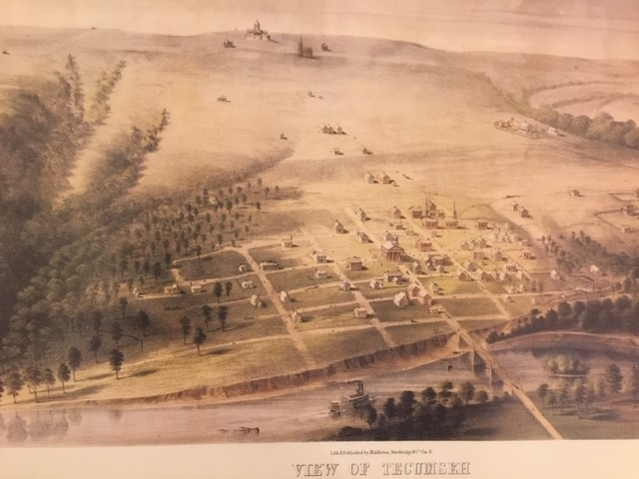
1869 Tecumseh Printed by Middleston, Strobridge & Company of Cincinnati. This 17 ¾” by 28” lithograph displays Tecumseh as it was in the late 1860’s. Call Bob Totten at 785 234 6097 or email us at Shawneecountyhistory@gmail.org for details on how to get these prints. $15 dollars plus shipping and handling.

